# Configuration of “Problems” view

I use the Problems view all the time, mainly to quickly see the following:

* Any problems beneath something (one/several projects, a package, …) that I select in the Project Explorer
* To see all problems of the class I am currently working on/looking at

In my opinion, the best configuration is thus to make the Problems view reach to current selection. (By default, it shows ALL problems globally, which I do not find very usable)

To configure Problems view to react to selections

* Open Problems view (and let it always be open from now on!)
* Select the view menu (arrow), and then “Filters”
* Set it up like this: 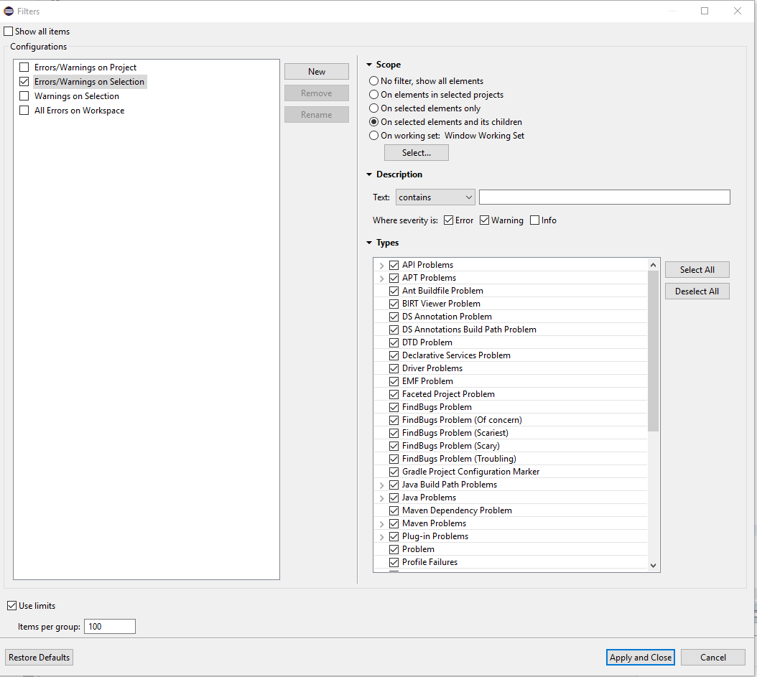
* The “Use limits” limits the number of items the problems view can present. You can unselect it, if you want to make sure to show all problems that are found (beneath your selection, if applied like the above)